
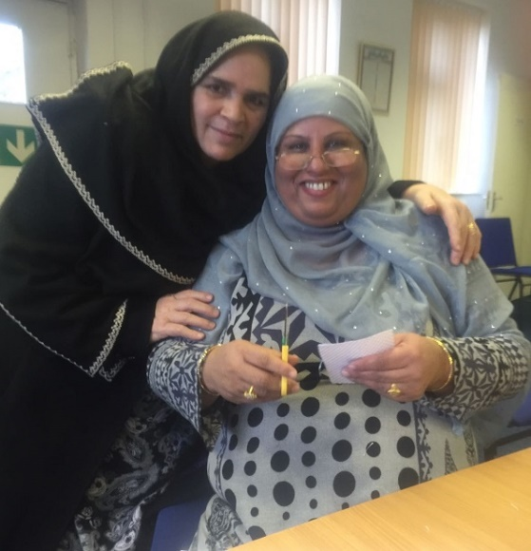
36 Godstone Road
Rotherham
S60 2PU

Tel: 01709 377750

Charity Number: 1091559
Company Number: 4146484

Volunteer Pack

Welcome
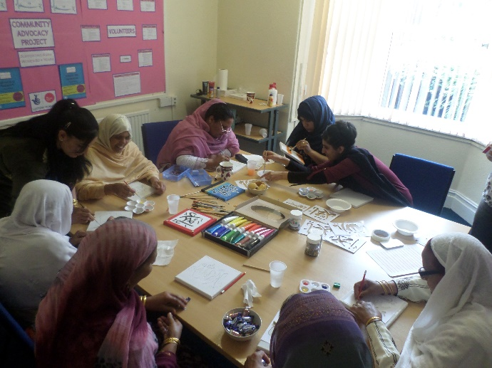
This pack provides you with all the information you need to help you decide whether you would like to volunteer for Tassibee Centre

Contents
Welcome 1
Contents 2
Volunteering 3
What’s it all about? 3
What’s in it for you? 3
What can we offer you? 3
Roles Available at Tassibee 4
Volunteer Role: Administration Volunteer 4
Volunteer Role: Volunteer Receptionist 4
Volunteer Role: Session Helper Volunteer 5
Volunteer Role: Volunteer Befriender 5
Volunteer Role: PR and Marketing Volunteer 6
Volunteer Role: Handy Man 6
Volunteer Role: Volunteer Driver 7
Volunteer Role: Volunteer Gardener 7
Sample Volunteer Agreement 8
Tassibee Volunteer Policy 9
Tassibee Volunteer Application Form 13

Volunteering

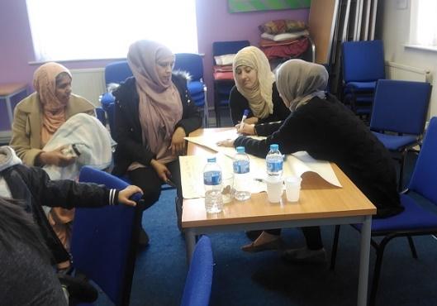
What’s it all about?
Volunteering is the giving of time and energy which brings:
- Benefits to Society
- Benefits to the individual or group you are helping
- Benefits to you, the volunteer
- A choice of activities for you to do

What’s in it for you?
It depends what motivates you! Volunteering with Tassibee will mean that you are making a difference (directly or indirectly) to the service users we work with. You can also
- gain new skills, knowledge and experience
- develop existing skills and knowledge
- Increase your chances of getting paid work as you can put the volunteering experience on your CV and get a reference
- gain confidence and self esteem
- meet new people and make friends
- feel valued
- get to know the local community
- But most of all …. HAVE FUN!

What can we offer you?
Volunteers are an integral part of this organisation and we recognise the huge contribution that volunteers make.
To show their value, we ensure all volunteers feel they are working in a safe and supported environment and their role continuously develops to meet their needs. We provide:
- Flexible working commitments
- A variety of volunteer opportunities
- Induction training
- Opportunities to access further training and development
- Social Activities
- Guidance and support from staff and other volunteers
- Volunteer expenses

Roles Available at Tassibee

Volunteer Role: Administration Volunteer
Role Purpose | Assisting the team with any administration duties seen as appropriate, contributing to the efficient running within Tassibee.
Specific Tasks | This role will include:  - General office duties including photocopying and filing  - Preparing information packs as required  - Undertaking computer work as required  - Carrying out other relevant tasks as required
Skills and Qualities Needed | - Excellent telephone manner and people skills  - Fully computer literate and comfortable with Microsoft Office and emails.  - Outgoing, friendly and proactive character.  - Good communication skills.  - Being able to use your own initiative but can ask for help when you need
Commitment | Flexible to suit volunteer

Volunteer Role: Volunteer Receptionist
Role Purpose | The purpose of the role of volunteer receptionist is to make visitors to the volunteer centre feel welcome and assist with general administration
Specific Tasks | - Welcoming visitors to the centre  - Answering and transferring phone calls  - Updating our databases  - Filing and photocopying
Skills and Qualities Needed | - Welcoming and friendly manner,  - Some familiarity with using IT and  - Willingness to learn
Commitment | Flexible to suit volunteer

Volunteer Role: Session Helper Volunteer
Role Purpose | The purpose of the role of help the project workers in their planning and delivering of healthy well-being sessions.
Specific Tasks | - Helping to prepare for the sessions  - Welcoming trainees to the sessions  - Working with the project workers to help trainees complete the activities during the sessions  - Carry out other relevant tasks as required
Skills and Qualities Needed | - Welcoming and friendly manner  - Interest in crafts  - Willingness to learn
Commitment | Flexible to suit volunteer

Volunteer Role: Volunteer Befriender
Role Purpose | Provide regular support on a one to one basis to an individual looking to achieve greater independence.
Specific Tasks | As a Befriender, your skills, personality and location will be matched appropriately to an individual that has requested support on a one to one basis. Every individual has different needs therefore what they require will be determined on their circumstances. So, your responsibilities could be:  - Offering emotional support through times of change.  - Helping individuals decide what to do next.  - Providing encouragement, guidance and support in finding a new job.  - Helping individuals achieve specific goals.  - Developing individual’s skills needed to achieve greater independence.  - Signposting individuals to access information and advice relating to their action plan  You will not be expected to provide any personal care.
Skills and Qualities Needed | We are looking for volunteers who are understanding, patient, empathetic and good at listening.
Commitment | We are looking for volunteers who can meet for  1-2 hours on a weekly/fortnightly basis with the client for at least 6 months and no longer than 18 months (exceptions can be made for shorter periods of volunteering).

Volunteer Role: PR and Marketing Volunteer
Role Purpose | Raise awareness of Tassibee within the local community
Specific Tasks | This role will include:  - Advertising and publicising the charity's activities  - Ensuring maximum coverage of charity events, both before and after  - Dealing with appeals for funds and attracting, donors and sponsors  - Establishing relationships with local organisations and businesses  - Maintaining publicity material such as display boards and leaflets and via social media  - Carrying out other relevant tasks as required
Skills and Qualities Needed | - Enjoy partnership and development work  - Good verbal and written communication skills  - Approachable and friendly  - Ability to work on own using initiative  - Open-minded and non-judgemental  - Good numeracy and attention to detail  - Past experience of PR and marketing work would be useful, but most important is enthusiasm and initiative  - The role requires computer skills and access to email
Commitment | Flexible to suit volunteer

Volunteer Role: Handy Man
Role Purpose | To carry out odd jobs around the building and garden
Specific Tasks | This role will include:  - Painting  - Minor Maintenance  - Gardening  - Carrying out other relevant tasks as required
Skills and Qualities Needed | - Interested in DIY  - Willingness to Learn  - Flexible approach
Commitment | Flexible to suit volunteer

Volunteer Role: Volunteer Driver
Role Purpose | The purpose of the role of enable clients to attend social activities and appointments that are support by Tassibee.
Specific Tasks | - To assist with the collection of clients to and from their own homes to enable them Tassibee services  - Ensuring that appropriate levels of confidentiality and safety are maintained in all areas of work
Skills and Qualities Needed | - Welcoming and friendly manner  - Hold a current driving licence  - Be dependable and trustworthy  - Vehicle that is roadworthy, reliable and suitable for clients’ needs  - Valid car insurance
Commitment | Variable

Volunteer Role: Volunteer Gardener
Role Purpose | We are now looking for volunteer gardeners who are willing to offer a few hours a week to help with maintain the upkeep of the gardens.
Specific Tasks | - Help to keep garden tidy and tend to bedding plants
Skills and Qualities Needed | - Welcoming and friendly manner  - Be dependable and trustworthy  - Interest and knowledge in gardening  - Flexible approach
Commitment | Variable

Sample Volunteer Agreement
Volunteers are an important and valued part of Tassibee. We hope that you enjoy volunteering with us and feel a full part of our team.
This agreement tells you what you can expect from us, and what we hope from you. We aim to be flexible, so please let us know if you would like to make any changes and we will do our best.
We, Tassibee, will do our best:
- To introduce you to how the organisation works and your role in it and to provide any training you need
- To provide regular meetings with your support worker so that you can tell us if you are happy with how your work is organised and get feedback from us. Your support workers name is [enter name]
- To respect your skills, dignity and individual wishes and to do our best to meet them.
- To pay your travel and meal costs up to our current maximum*
- To consult with you and keep you informed of possible changes
- To insure you against injury you suffer or cause due to negligence*
- To provide a safe workplace*
- To apply our Equal and Diversity Policy
- To apply our Volunteer Complaints Procedure if there is any problem.

I, [enter name] agree to do my best:
- To work reliably to the best of my ability, and to give as much warning as possible whenever I cannot work when expected (a minimum of 24-hour notice of non-attendance should be given if possible)
- To hold a current DBS check (if new one required, it will be paid for by Tassibee)
- To follow Tassibee rules and procedures, including health and safety, equal and diversity and confidentiality*
*More details on these issues are provided in the volunteer policy and handbook.
Note: This agreement is in honour only and is not intended to be a legally binding contract of employment.

Signed (Volunteer): Date:

Signed (Chief Executive): Date:

Tassibee Volunteer Policy
Purpose and Scope
This policy is intended to provide the framework for our involvement with volunteers and help define the role of volunteering within Tassibee. This policy is not intended to create a legally binding contract or employment relationship.
The purpose of this policy is to meet Tassibee's obligations to its clients to reduce risks associated with service delivery. It applies to all staff and volunteers of the association.
Principles
Tassibee:
- Recognises that voluntary work brings benefits to volunteers themselves, clients and to paid staff
- Will ensure that volunteers are properly integrated into the organisational structure and that mechanisms are in place for them to contribute to Tassibee’s work
- Will not introduce volunteers to replace paid staff
- Expects that staff at all levels will work positively with volunteers and, where appropriate, will actively seek to involve them in their work
- Recognises that volunteers require satisfying work and personal development and will seek to help volunteers meet these needs, as well as providing the training for them to do their work effectively
- Will endeavour to identify and cover the costs of involving volunteers
- Recognises that the management of volunteers requires designated responsibilities within specific posts
- Will endeavour to involve volunteers from a wide range of backgrounds and abilities and ensure our volunteering opportunities are as accessible as possible.
Volunteering within Tassibee may encompass a variety of roles including peer support, a mentoring or helper capacity, fund raising, presentation of information sessions and awareness activities.
The process of discerning suitability for peer mentor roles (and to undertake training for this role), the following skills, requirements and personal qualities should be considered.
- can put aside their own issues in order to facilitate others dealing with their issues
- Be willing to complete training in peer mentoring skills
- can commit to a significant length of time to the role
- Demonstrate certain personal characteristics of effective mentoring (e.g. courage, willingness to model, ability to be emotionally present to group members, a sincere interest in the welfare of others, respectful, belief in the group process, openness, non-defensive in copying with attacks, stamina, self-awareness, willingness to learn and seek new experiences, sense of humour, inventiveness).

Procedures
Diversity
Tassibee is firmly committed to promoting diversity in all areas of our work and welcomes volunteers from all backgrounds and experiences. Tassibee has an Equality and Diversity Policy and regularly reviews our progress towards diversity. Volunteers are expected to have an understanding of and commitment to our Equality and Diversity Policy.
Recruitment
People interested in volunteering as invited for an informal talk with the appropriate contact person. They will be given an information pack including general information about Tassibee and specific information on the volunteer post in which they are interested. Volunteer Trustee Members will be given a role specific induction and information pack by the Chief Executive.
During the discussion, the contact person will complete a simple registration form appropriate to the role that they are applying for with the applicant and they will be asked to supply two references. Where applicants are not placed in the role applied for, they will be provided with feedback and given the opportunity to discuss alternative volunteering roles both with Tassibee or other voluntary organisations.
DBS Checks for Volunteers
Tassibee has a duty of care to take all reasonable steps to protect its clients and members from harm. Tassibee requests DBS checks, prior to the confirmation of volunteer contract, at the expense of Tassibee. All volunteers who may be in situations where they are alone with clients must obtain clearances before starting their role.
This information will be dealt with in the strictest confidence and will not necessarily prejudice the person being accepted for voluntary work. The existence of a criminal record will be decided on an individual basis at the discretion of the Chief Executive and/or the Board.
Process for DBS checks
- Tassibee Volunteer Agreement and application for DBS check is given to potential volunteer to be signed and then returned to Tassibee.
- The volunteer must provide three current forms of proof of identity i.e. previous or current driver’s license with photograph, passport or birth certificate and / or utility bills. These will be photocopy of proof of identity and attached to the DBS application form.
- A Tassibee staff member should sign as witness.
- A photocopy will be taken of all documents for office records.
- The DBS will then be passed on to Voluntary Action Rotherham to process the application through their “DBS Check Service”.
- Once you DBS has been processed, you will be sent DBS certificate. Bring this into the office, so a copy can be made and added to your file.
- Documents are placed in secure filing.

Volunteer Agreements and Voluntary Work Outlines
Volunteers will receive a role description and volunteer agreement containing full information about their chosen area of work and a clear idea of their responsibilities and the volunteer’s responsibilities to them.
Induction and Training
Volunteers will be given induction and training appropriate to the specific tasks to be undertaken.
Support
Volunteers will be assigned a named contact person who will provide regular support. Support sessions will provide the opportunity for ongoing dialogue about the development of the volunteering role and any advice and guidance as needed.
The Volunteer’s Voice
Volunteers will be consulted in decisions which affect them. Tassibee is committed to developing consultation and representational procedures for volunteers.
Records
Minimum details will be kept on volunteers. This will include the registration form, references, placement details, crisis contact, correspondence and any other relevant information in accordance with Tassibee confidentiality policy.
Expenses
Tassibee will ensure that there is a clear and accessible system to enable volunteers to claim out of pocket expenses.
Insurance
Tassibee currently has both Public Liability and Professional Indemnity Insurance in place if a member of the team brings a claim of negligence against us. As an individual you are not ‘covered’ as such, it is the organisation VAR which is covered. It is important to keep in mind that everyday accidents can and do happen; they’re nobody’s ‘fault’. If you rely on a wage outside of your volunteering, you may want to consider exploring your options in terms of Loss of Earnings cover to safeguard yourself against this. If a volunteer is using their car to transport volunteers, they need to ensure they are covered on their own car insurance and evidence will need to be provided.
Health and Safety
Tassibee will take all reasonably practicable steps to ensure the volunteers’ health, safety and welfare while at work in accordance with Tassibee Health and Safety policy.
Equal Opportunities
Volunteers and staff will work in accordance with Tassibee’s Equality and Diversity Policy and will prevent discrimination on any grounds.
Problems
Tassibee has a Volunteer Complaints Policy to help deal with grievances that volunteers may have. In line with this policy volunteers have the right to discuss any concerns they may have with their named contact at any time.
If the contact person is unable to resolve the problem, they will refer the matter to the Chief Executive and ultimately the Board of Trustees, with the permission of the volunteer.
Tassibee has a Problem-Solving Policy on how it will deal with any unsatisfactory performance regarding a volunteer.
Endings
When volunteers move on from their role at Tassibee they will be asked to provide feedback on the volunteering experience by way of an exit questionnaire. They will also be given the opportunity to discuss their responses to the questionnaire more fully with their support worker.
Based on their voluntary work, volunteers will have the right to request a reference. Volunteers will be supported to move on to other options.
Monitoring and Evaluation
Tassibee will systematically monitor and evaluate its use of volunteers with reference to this Volunteer Policy.

Updated November 2020
Next Review November 2021

Tassibee Volunteer Application Form
This form is used for us to record important information about our volunteers. It will be completed during the initial informal discussion. All information will be kept confidential.
Your Details
Full Name
Address
Home Number
Mobile Number
Email
Date of Birth
Languages spoken other than English

In the event of an emergency, who should we contact on your behalf?
Name

Phone number

Relationship

Supporting You
Do you consider yourself to have a disability?
Yes | No
If yes, please describe:
Are there any other areas of support you might need to enable you to volunteer with us?

References
Before we engage volunteers, it is our policy to seek two references. Please give us details of your referees below.
Name
Address
Email (if known)
Name
Address
Email (if known)
Your Skills
Previous volunteer experience
Why would you like to volunteer at Tassibee?
Are there any particular programs or roles at Tassibee that you are interested in volunteering for?
Are there any areas, programs or roles that you would prefer not to work in?
Do you have preferred days and times that you would like to work?

Thank you for the support from:





